**Practice Quiz 1**

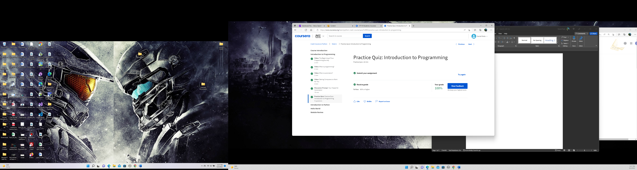

**Practice Quiz 2**

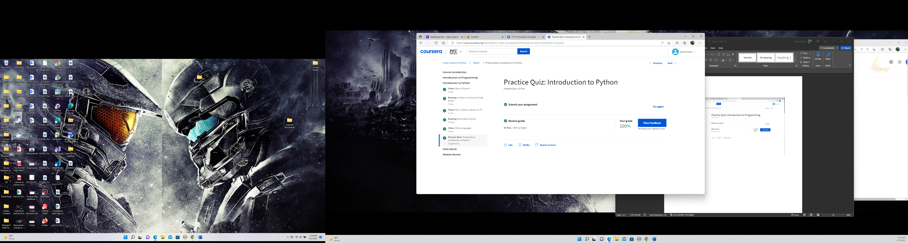

**Practice Quiz 3**

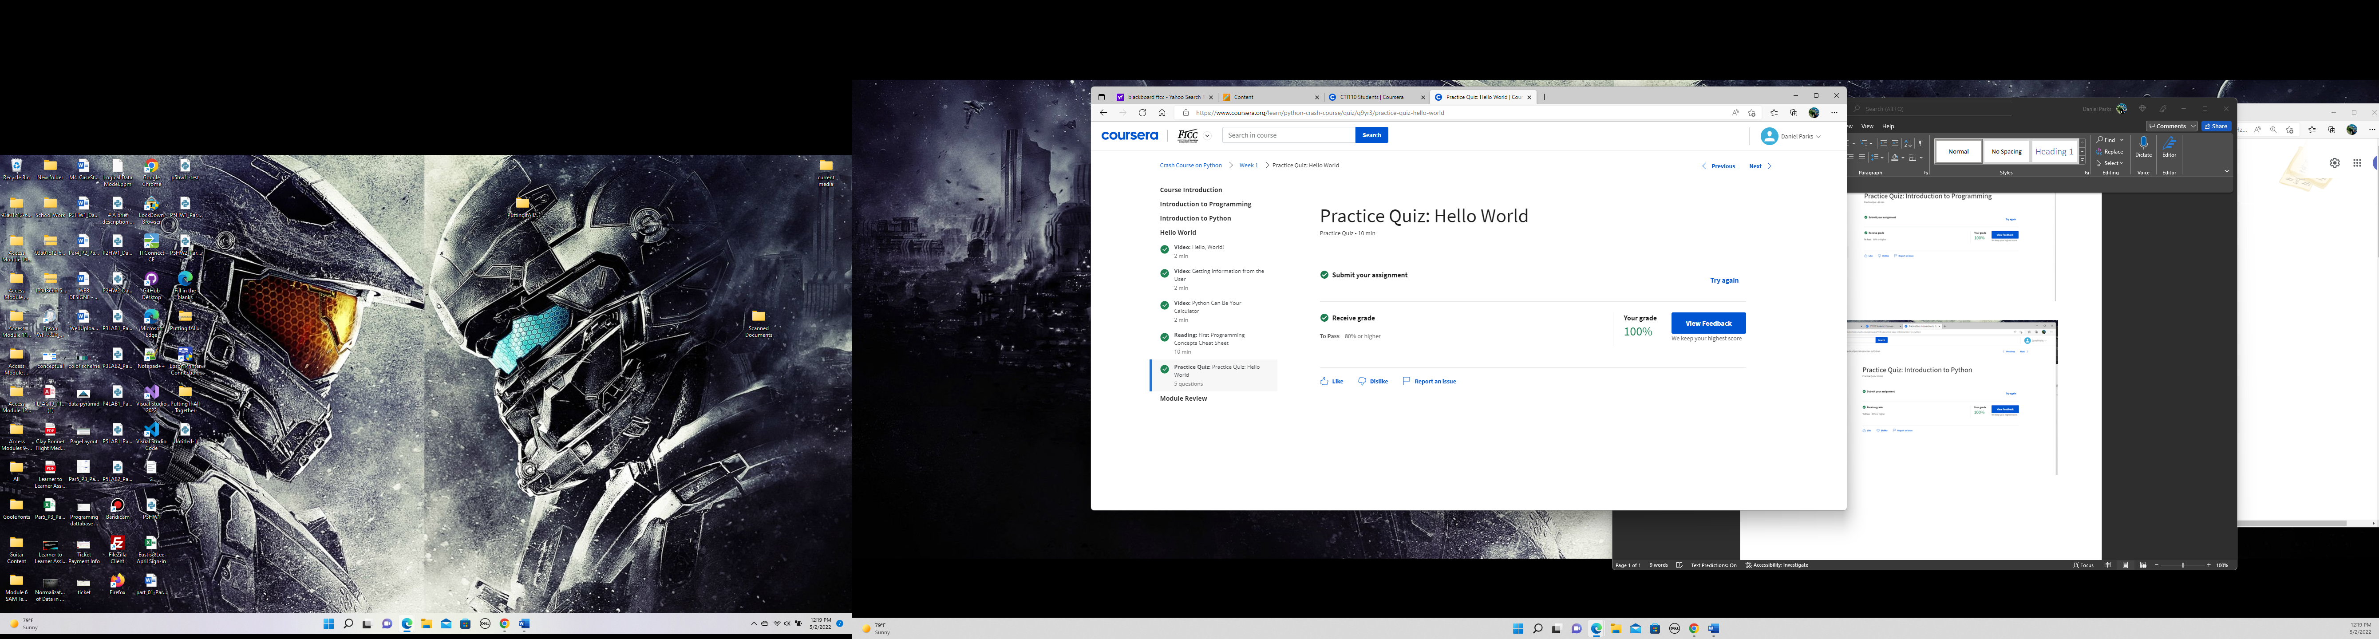

**Module 1 Graded Assessment**

